International Darth Vader

System Concepts and Design Challenges

Christopher Woedy

Rachel Williams

Logan Adams

Anthony Gill

Sponsor: Pierce Freelon

**Table of Contents**

Introduction……………………………………………………………………………….Page 2

Design Brainstorm……………………………………………………………………….Page 2

Design A……………………………………………………………………………….Page 2

Design B……………………………………………………………………………….Page 3

Design C……………………………………………………………………………….Page 4

Design Pros & Cons………………………………………………………………….Page 5

System Block Diagram………………………………………………………………….Page 6

Design Challenges………………………………………………………………………Page 9

Conclusion……………………………………………………………………………….Page 12

**Introduction**

The International Darth Vader product is a social music education tool that will be used to trigger inspiration in students around the world. By using the International Darth Vader, students will be introduced to other cultures, thoughts, and feedback that will encourage critical thinking with a diversified approach. The device will work by linking up with the cloud through a broadcasted Wi-Fi connection. Through the cloud, the International Darth Vader will be able to download voice, music, and media clips flagged for that particular device from a server backend. The backend will receive this data from mobile clients and store the information locally until requested by the International Darth Vader product. Once data has been requested, the server backend will store these files in a server-side archive.

**Design Brainstorm**

In order to effectively create a system design overview, the team first had to brainstorm potential design ideas. This process involved breaking down the International Darth Vader system, mobile system, and server system into their core components for analysis as well as identifying the major challenges and concerns of designing the components of each system. However, not every design was successful. This section details a couple different potential designs highlighting the positives and negatives of each design. These designs focus on the high-level systems and how they interact with each other before breaking the system down into components.

**Design A**

The first design involved theorizing the possibility of each Darth Vader hosting as its own server. The benefit of this would be that it would cut down on the costs of hosting and managing a separate server systems. Unfortunately, this was a “wouldn’t it be cool” approach as this design’s cons significantly outweighed its pros. The design would have required that the Darth Vader system draw much more power and would not be able to operate without being plugged in. Another major drawback is that the system would need to have a 99.98% internet uptime which would remove the wireless aspect of the product. Because the device is intended to store and playback media, the system would need access to a vast array of digital storage. Thus, the design was eventually scrapped as it would make the expected product requirements for the project unattainable.

Below is the system diagram for Design A:

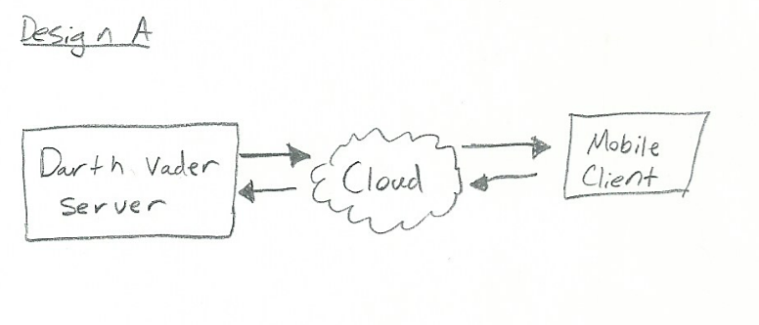

**Figure 1. Design A High-Level Diagram**

**Design B**

Realizing that the server system would need to be separated from the Darth Vader system, discussion began on how the Darth Vader system would inevitably connect to the internet. The immediate and obvious choice was through Wi-Fi, but this raised the question: how would the device be configured to connect to a wireless network? One interesting thought was, what if it didn’t need to be configured? The idea of the Darth Vader system piggybacking off the mobile client’s internet access was then considered. The benefit of this method was that the device would have a simplistic bluetooth pairing process and then would be ready for use. However, there were drawbacks as well. The Darth Vader system would require a mobile device in order to use it properly. Mobile phone security might restrict access to low-level hardware like Wi-Fi and Bluetooth modules. This design was eventually scrapped because it did not align with Pierce’s expectations for the Darth Vader system to connect independently to Wi-Fi.

Below is the system diagram for Design B:

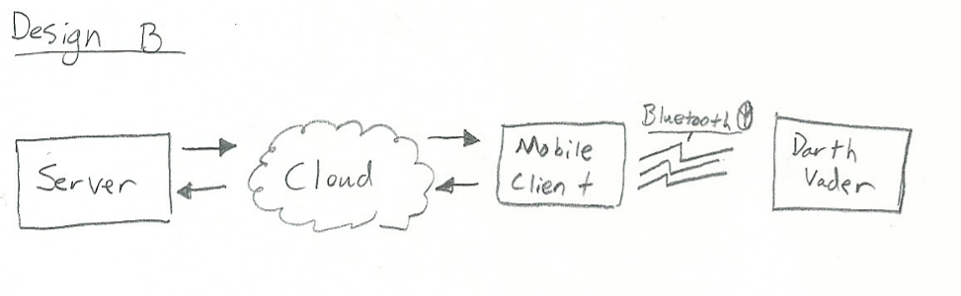

**Figure 2. Design B High-Level Diagram**

**Design C**

Learning from the mistakes of previous designs, another concept was pieced together which we believe fits Pierce’s expectations as well as the design requirements. The chosen design for the project utilized a mobile client that would upload content to a backend server. Once approved by the server and requested by the Darth Vader system, the content would be sent over the internet to the Darth Vader system. The Darth Vader system would be linked to the internet via Wi-Fi and store content locally for playback. This implementation had the server as a central data point where the client would upload the data and the Darth Vader module would download it. This also creates simplicity on data throughput aka client uploads, Vader downloads.

Below is the system diagram for Design C:

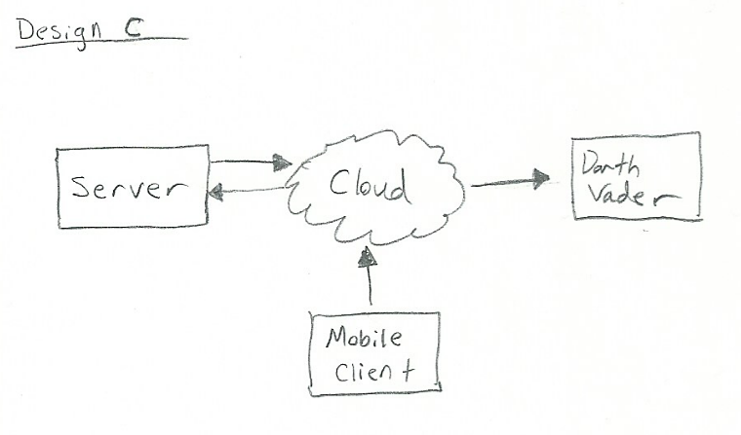

**Figure 3. Design C High-Level Diagram**

**Designs Pros & Cons**

| **Challenge** | **Design A** | **Design B** | **Design C** |
| --- | --- | --- | --- |
| System shall connect to the cloud to communicate with a backend server | CON - Vader would need to meet a high uptime and have a major increase in power consumption if acting as a server. | CON - Vader will require a mobile phone for connectivity. | PRO - Server’s, Client’s, and Vader’s internet connections are independent. Vader doesn’t rely on client. |
| The product shall be under $50 excluding Vader figure. | PRO - Cut overall cost by not having to operate and maintain a separate server system  CON - Vader’s overall product cost would increase. | PRO - Bluetooth modules for connectivity are generally cheaper than most WiFi modules | PRO - Meets Pierce’s design expectations.  CON - WiFi modules are more expensive than bluetooth modules. |
| The system shall be able to play-back up to ten 15 seconds clips of voice and music uploaded from a client session. | PRO - Vader would hold all the clips locally.  CON - Vader would need to house a significant amount of storage. | PRO - Local stored clips downloaded from server.  CON - Requires client to download from server | PRO - Local stored clips downloaded from server from Vader’s own WiFi connection. |

**System Block Diagram**

Having decided the high-level system implementation, the project was broken down into three low-level system diagrams. Each system identifies components of the final product and how they interact with one another. The first system block diagram listed below is the implementation of the Darth Vader module.

The outline below details the primary components linked to the microcontroller such as the battery-driven power supply, the Wi-Fi module, the onboard speaker system, the screen/interface, and the onboard digital storage. We chose the battery power supply unit as a solution to address system mobility. Although the system does not have an emphasis on mobility, it is supposed to be movable by one person and easily configured for different locations. For this same reason, we wanted to have a power switch to easily power the Darth Vader module down for transport or storage allowing better energy conservation. The Wi-Fi module was selected for mobility, connectivity, and to meet the desired product requirements. Utilizing a Wi-Fi module allows the device to connect to any common-use 802.11 standard wireless router and download voice/music clips to the local system. The onboard audio package was to meet the speaker upgrade requirement as well as address the voice modulation requirement. The voice clips will be modulated to sound similar to Darth Vader. Local digital storage will be used to store voice/music clips downloaded through the cloud from the server backend.

Below is the system diagram for the Darth Vader system:

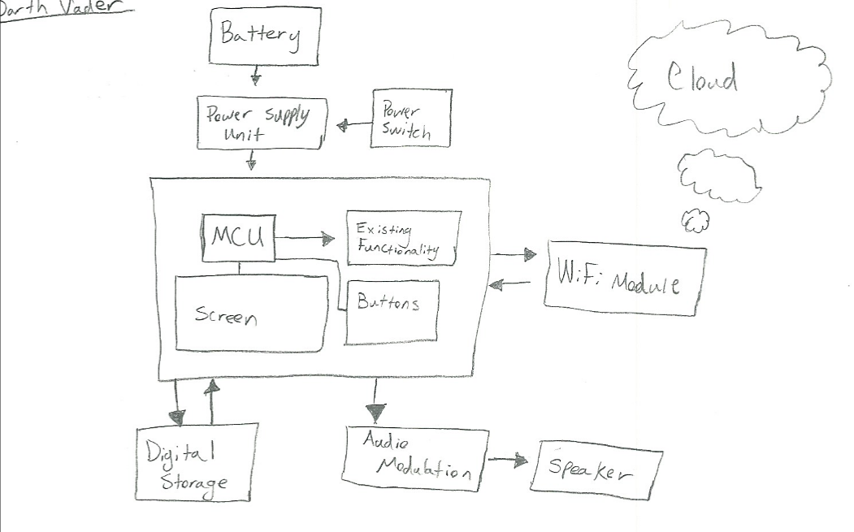

**Figure 4. Darth Vader System Diagram**

The next system diagram below details the server system. The three major concerns for the server system are administration, storage, and of course the Darth Vader server-side application. Storage is important because the server will be saving a significant amount of media from the client application as well as archiving media from the database. The server will also need to store the operating system files and server backups. Administration is another major component of the server system as this aspect includes system backups, security settings, and system drivers / performance. Server administration is important in order to ensure system longevity and reliability. Of course the most important feature for the success of the overall products is the Darth Vader server application. This application will allow the automation of pushed content as well as content management. Management of the application is important because it prevents inappropriate content reaching the end-user. This is essential due to the educational nature of the device and potential exposure to children.

Below is the system diagram for the server system:

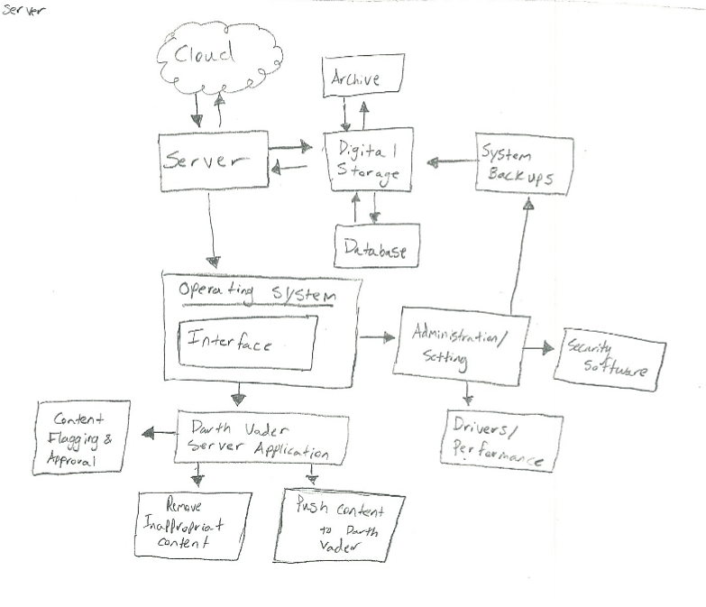

**Figure 5. Server System Diagram**

Finally, the mobile client system diagram is shown below. The system diagram for the mobile client is slightly different because a design choice in hardware on the client would not be obtainable. Instead, the development platform, which gives access to the phone’s hardware API’s, was chosen. A majority of the system blocks are application-based rather than hardware-based. The client must be able to upload text and sound to the server meaning access to microphone hardware on the phone will be a necessity. Furthermore, an application text interface would be needed to parse text information from the user. There will be a way to direct content to different Darth Vader systems from the client through a form of tagging.

Below is the system diagram for the client system:

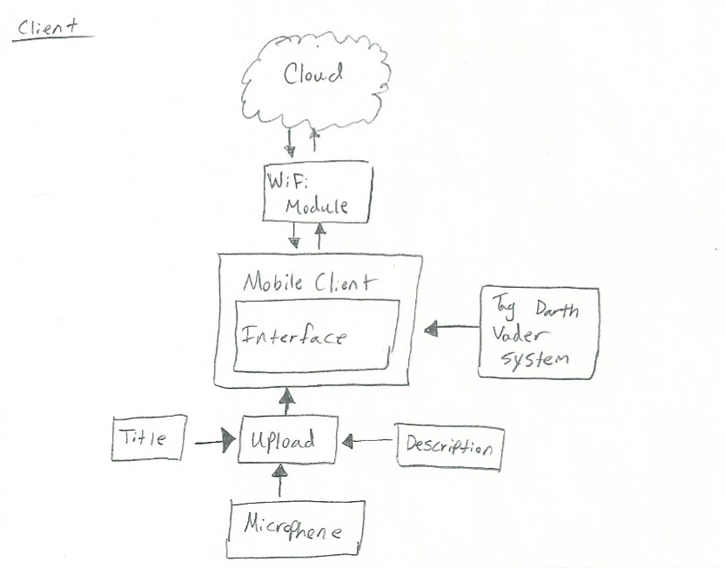

**Figure 6. Client System Diagram**

**Design Challenges**

This section includes highlights and discussion on the different design challenges for the three primary system diagrams. Each design challenge is outlined with a color-coded square to make them easily identifiable.

Below is the image of the Darth Vader system diagram with outlined design challenges:

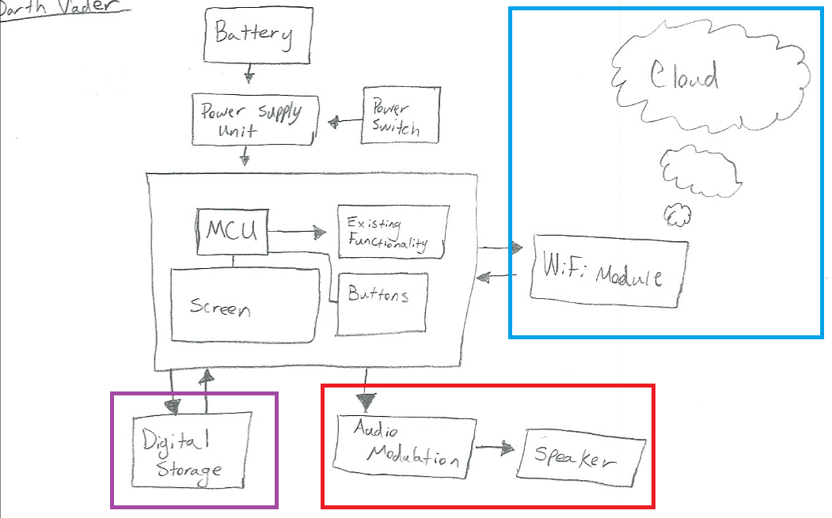

**Figure 7. Darth Vader Design Challenges**

* **Wi-Fi Module (Blue)**: The Wi-Fi module may present a configuration challenge as the Darth Vader system does not have a good way to enter text based data. This will present a challenge because the Wi-Fi module will need string data to be configured to different SSID’s and to enter security keys for these devices.
* **Audio System (Red):** The audio system will present an audio modulation challenge as well as the difficulty of upgrading the current speaker system on the device. Our team has minimal knowledge of digital signal processing and will have to learn more in this field for proper implementation.
* **Digital Storage (Purple):** Addition of digital storage may be a challenge as the device will need to be configured to accept an external memory device. This will vary based on the selected microcontroller and storage solution.

Below is the image of the server system diagram with outlined design challenges:

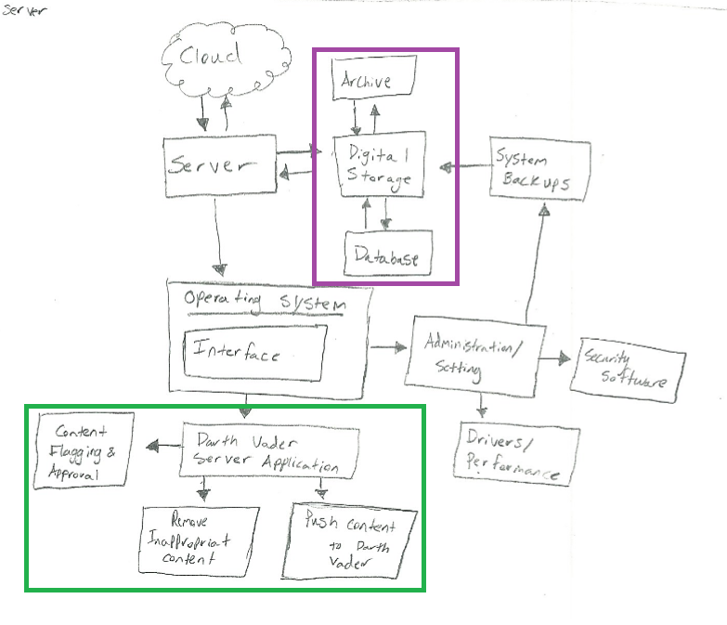

**Figure 8. Server Design Challenges**

* **Digital Storage (Purple):** The server will need to have ample storage for saving audio data. Archive may need to implement compression algorithm to save storage space on the server when preserving old files on the database.
* **Server Application (Green):** The server-side application will need to have code that opens network connections for multiple clients from various parts of the world. The application will also need administrative features such as content removal.

Below is the image of the mobile client system diagram with outlined design challenges:

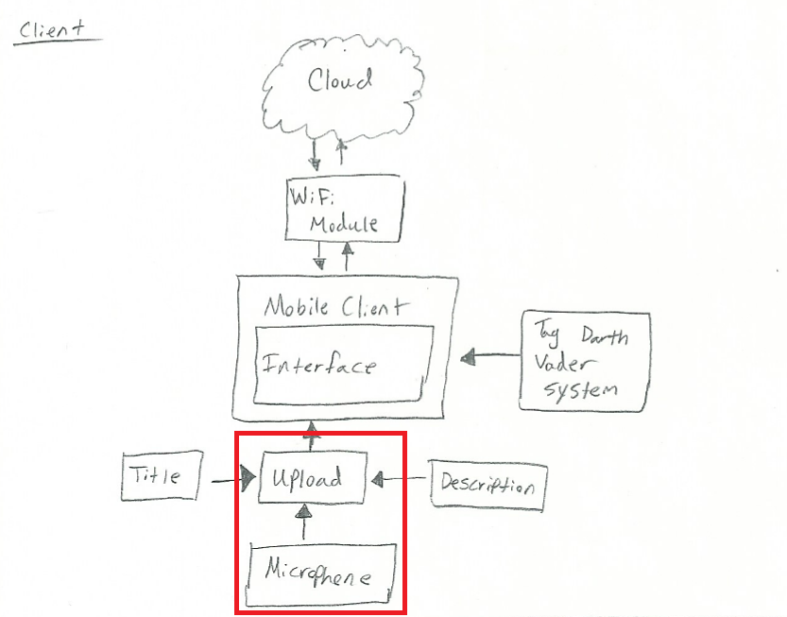

**Figure 9. Mobile Client Design Challenges**

* **Interface Audio Device (Red):** Working, interfacing, and uploading audio files will be challenging as we will need to learn and apply digital signal processing. This will also require access to the mobile client’s audio hardware for recording and playback.

**Conclusion**

The International Darth Vader project posed a few unsuccessful preliminary design concepts which resulted in more analysis of the system and refinement in its concept to achieve a final system design to pursue moving forward. Each design challenge helped to further evaluate what other components were essential to the system and how those components could be obtained when working on the project over time.